Digital Literacy Project Report

Name: Kasak Fitkariwala
Registration Number: 25BAI10884
Course: CSE0001 Digital Literacy
Program: B. Tech Computer Science and Engineering
University: VIT Bhopal University

Introduction

Digital literacy refers to the ability to use digital devices, internet services, and online platforms in a safe and effective manner. In today’s academic environment, students depend on digital tools for learning, communication, and project work.
The main aim of this project was to develop practical knowledge of digital platforms such as GitHub, coding websites, Google Forms, and professional communication methods. The project also focused on understanding cyber safety and responsible use of online resources.
All the tasks were completed step by step and organised in a GitHub repository. This report explains each task along with the work performed and learning outcomes.

Task 1 – Infographic Creation

In this task, a digital infographic was created using Canva to explain the concept of digital literacy. The infographic included topics such as basic digital tools, safe internet usage, email etiquette and responsible online behaviour.
A suitable template was selected in Canva, and the content was added in a simple and clear format. After completing the design, the infographic was downloaded and uploaded to the GitHub repository.
This task helped in understanding how to present information visually using digital tools, and I was surprised to notice how Canva had so many templates for infographics, which were diverse and could be used with versatility.

Task 2 – Digital Portfolio

In this task, I created profiles on different online platforms such as GitHub, LinkedIn, and StackOverflow. These platforms are important for building a professional online presence.
On these platforms, one can share basic details such as education, job interests and course information. I can also share my creativity and coding skills on such platforms, which will help me connect with like-minded people and also collaborate on projects.
This task helped in understanding how digital platforms can be used for learning and future career development.
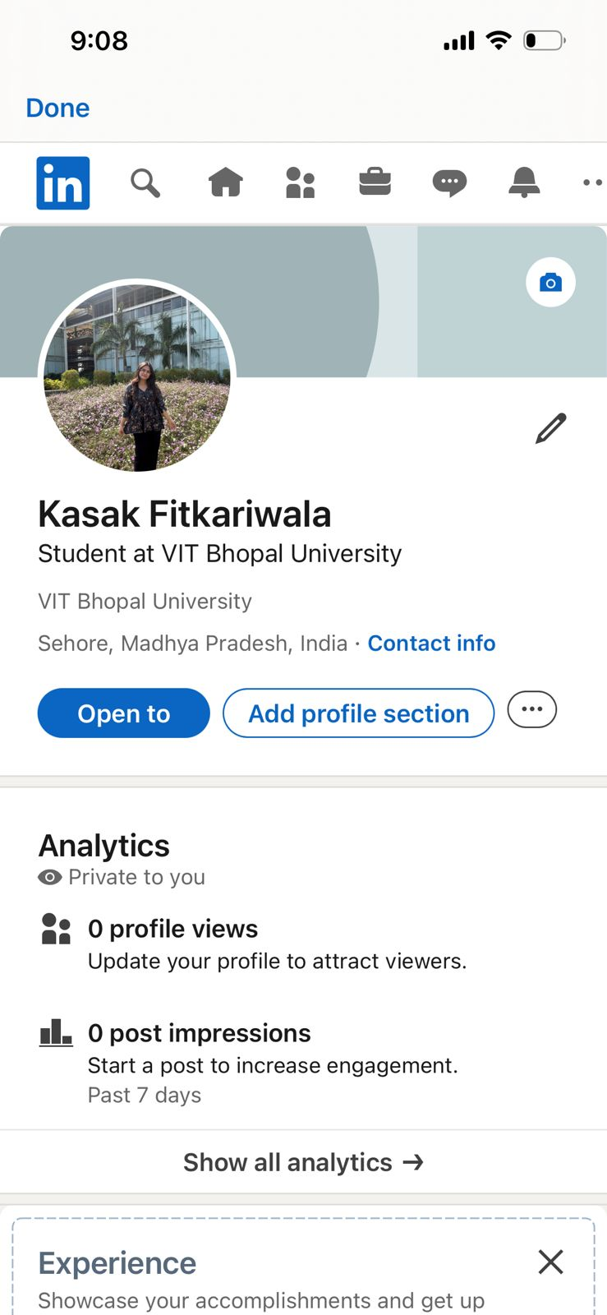
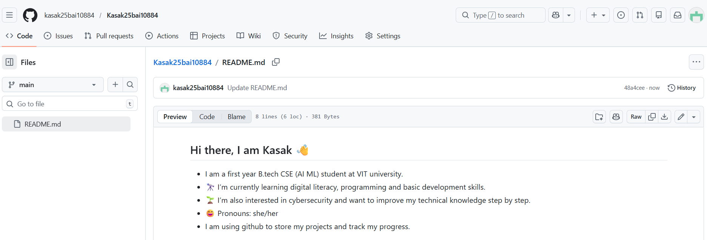
Task 3 – Coding Platform and Google Form

This task involved using a coding platform, which helped to improve my digital skills and the activity helped me understand basic problem-solving. An account was created on HackerRank, and basic problems were solved to understand how coding platforms work.
I used Google Forms for collaboration to spread awareness about Digital Literacy. A Google Form was created with multiple questions related to digital literacy. The form included different types of questions, and the data analysis was done through responses.
These platforms are academically helpful as they enhance practical learning and support teamwork. The coding platform helps build logical thinking, while collaboration tools help in collecting feedback, sharing ideas, etc. This task helped in improving online collaboration skills and digital literacy.
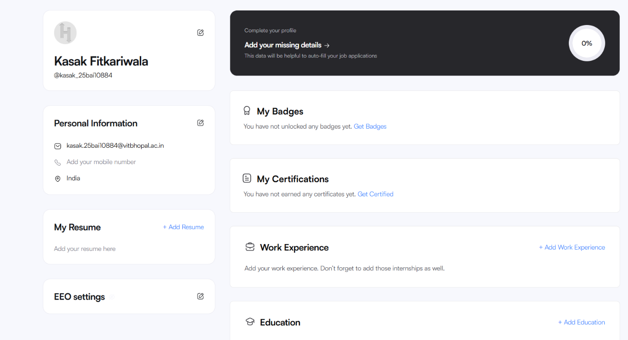

Task 4 – Email and Social Media Etiquette

In the task, two professional emails were written to understand formal communication. One was written for assignment submission, and the other was related to an internship inquiry.
A case of poor digital communication can be seen in a workplace where an employee received an unclear email from their manager about a project deadline. The email only mentioned “submit it soon” without specifying an exact date or time. The employee assumed they had a few days, while the manager expected it by the end of the same day. This misunderstanding led to missed deadlines, client dissatisfaction, and unnecessary stress within the team.
This situation could have been avoided with clear and precise communication. The manager should have mentioned a specific deadline, such as “submit by 5 PM today,” and possibly confirmed understanding through a follow-up message. Similarly, the employee could have asked for clarification. Using clear language, proper email etiquette, and confirming key details can prevent such issues.
This task helped in improving communication skills in a formal environment and understanding proper usage of social media platforms to maintain your professional reputation.

Task 5 – Cybercrime Case Study

In this task, a case study on online UPI fraud was prepared. The case explained how attackers trick users into making payments through fake requests or messages.
During the case study of the particular topic, I was surprised to see how only a few people had knowledge about cybercrime and the risks associated with it. A large number of people have been the victims of UPI fraud due to a lack of knowledge.
One habit that I would surely put into place from now on is to never trust a link from an unknown source and report it as spam.
A prevention checklist was also created, including safety measures such as verifying payment requests, avoiding unknown links, and not sharing personal details.
This task helped me understand cyber risks and how to stay safe while using digital platforms.

Conclusion

This project helped in developing practical knowledge of digital tools and platforms. It improved skills such as creating content, managing online profiles, writing professional emails, and understanding cyber safety. The use of GitHub for organizing all tasks also helped in learning how to present work in a structured manner. Overall, this project was useful in building essential digital skills required for students.
- GitHub profile: https://github.com/kasak25bai10884
- LinkedIn: https://www.linkedin.com/in/kasak-fitkariwala-3620663bb?trk=contact-info
- HackerRank: https://www.hackerrank.com/profile/kasak_25bai10884
- Google form: https://docs.google.com/forms/d/e/1FAIpQLSeYrWA5nZqurwqFTHASJznLhU7EmioIGSbBjtMuqQYL2A8aDA/viewform?usp=publish-editor

